Disaster Readiness & Risk Reduction | 4th Quarter
Mini Performance Task 5
March 4 2021
Page 173-175

- Prepare an emergency survival kit.
  - Flashlight and Batteries
  - Pocket Knife
  - First Aid Kit
  - Emergency Money
  - Water Bottles
  - Canned Goods
  - Mobile Phone
  - Valuable Documents
- Prepare an emergency escape route.
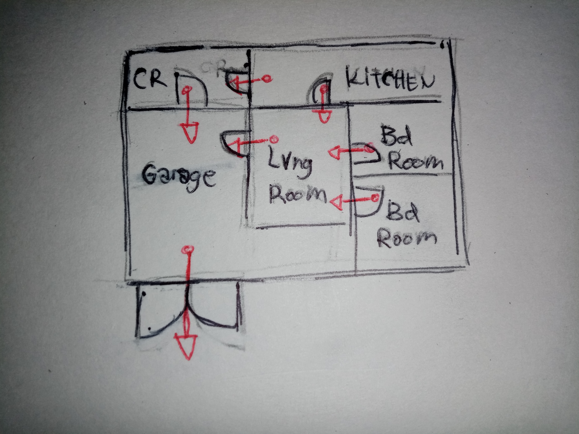
- Designate a meeting place for you and your family members.
- 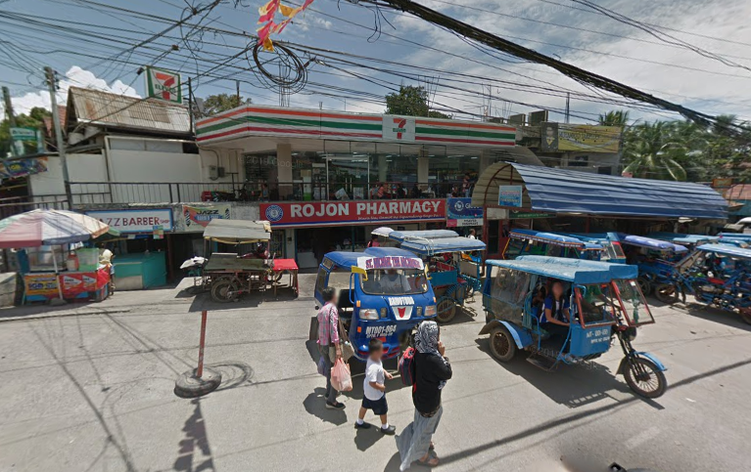
- 7-Eleven near Cagayan Highway

- Improvise a personal emergency identification card with a whistle and a pen light.
  - Name: Ahmad Badron
  - DoB: June 29 2004
  - PoB: Dammam Maternity Hospital, Dammam, KSA
  - Blood Type: O-
  - Sex: M
  - Overseas No.: +966 55 758 1975
  - Philippine No.: +639 49 655 6319
- Know the nearest evacuation center in your area.
  - 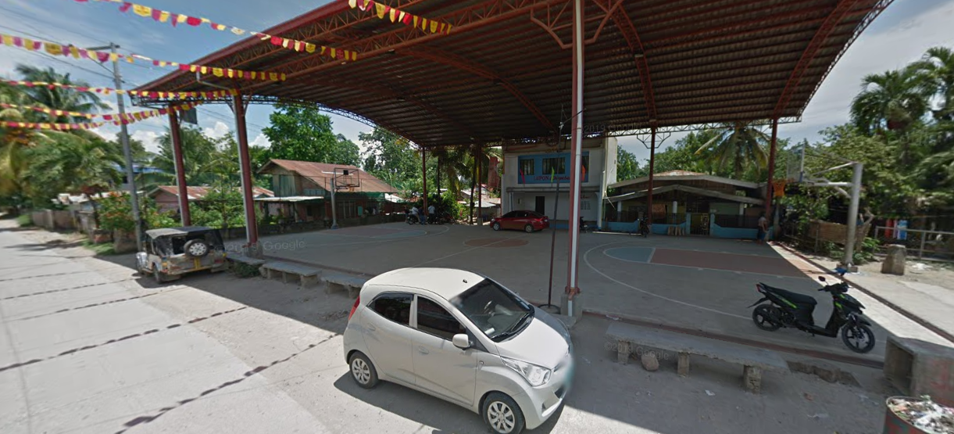
- Barra Covered Court

